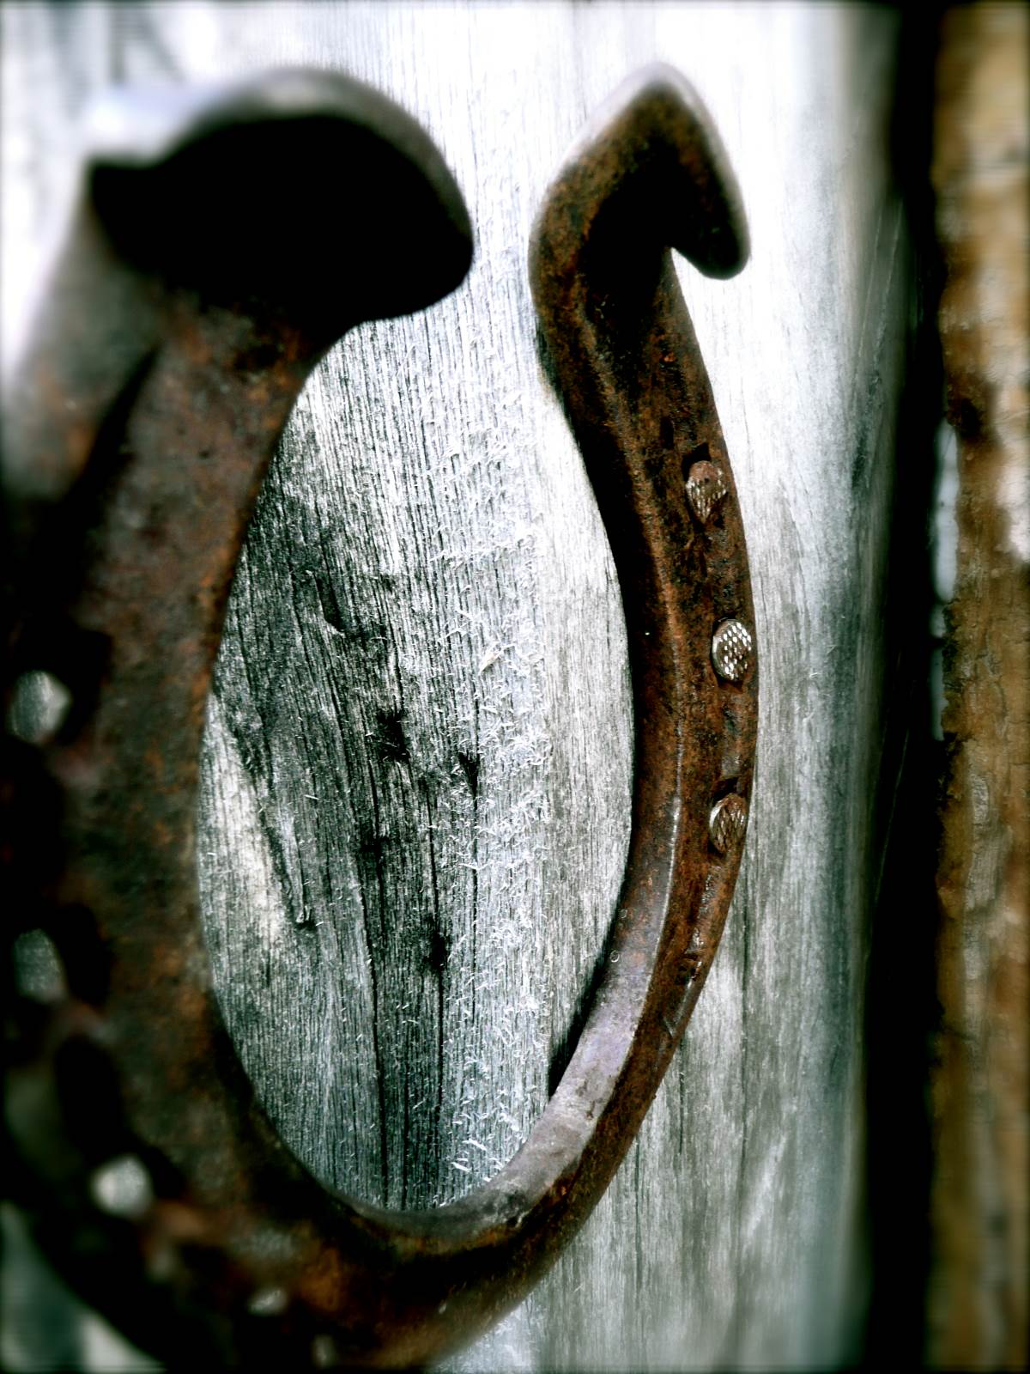

KIT

October is autumn in Mongolia and can be pretty cold. You need to think about having the following clothes

- Your own good winter sleeping bag if you have one. We provide them if not, but best having one’s own.
- Silk liner for sleeping is a good tip.
- Hats. Warm hat for cold. Hard hat /or other for riding.
- Merino thermals. Leggings and 2 for upper body might be necessary.
- Fleece or wool shirt.
- Good quality thick wool jumper
- Coat to keep out wind. Oilskin or other. Try and avoid bright colours as they can spook horses.
- Good thick and warm riding trouser that wears well and going to keep you warm.
- Waterproof trousers, can be very useful to keep cold out (rain or snow)
- Good long riding boot or boot and chap combo. What ever is comfy for both on and off the horse. (advise Ariat – as tried and tested by us to last) http://www.ariat-europe.com/uk
- A light slipper style shoe for the ger (yurts).
- A comfy warm particle non riding shoe for walking around and at camps.
(advise www.vivobarefoot.com)
- Good scarf
- Warm and wind proof gloves for riding. Essential. Bring 2 pairs if necessary.
- Warm socks

Other Stuff

- Small Pen knife
- Head torch. Head torch
- Facial and hand sun screen (block)
- Skin moisturizer (air very dry)
- Lipsol – with high SPF factor
- Water bottle
- Sun glasses
- Travel towel (towels will be provided but, nice to have a travel towel I think)
- Eco bio degradable wet wipes
- Personal medical kit with personal medicines that you might need.

Recommended links for buying kit:

http://www.raymears.com/Bushcraft_Products/

ACCOMODATION

HOTELS - In Ulaanbaatar, we use one of the city’s best options, the Ulaanbaatar Hotel. Locally run and operated, it is located just off Sukhbaatar Square, which is ideal for exploring the city on foot.
HOMESTAYS – accommodation with and alongside, nomadic families. Furnished gers lack full bathroom facilities (only an exterior tented unisex portaloo is provided).
GERS – this is the Mongolian nomadic home. We will spend most of the trip living in gers. They are very simple, but cosy. They have a wood/ coal burning stove inside, so they get very warm when the fire is roaring. They do not have bathroom facilities. Warm water will be brought to the tents for hand and face wash, and bird bathing. Loo is in tent outside at each camp.
CAMPING - You will be provided with all necessary camping equipment, including a sleeping bag if you require.
RUSTIC AMENITIES - we feel that the unique, rural & secluded locations where we choose to be are the most spectacular and friendly, providing our guests with a more rewarding and authentic Mongolian experience.

TRAVEL

- For those of you who arrive early in the morning, you may like to consider having an early check in at the hotel. It is possible that rooms aren’t available until after midday. An early check in will cost $90 per single room.
- Let us know if there are dietary requirements or health matters that we should know about

- NO VISA REQUIRED FOR UK PASSPORT HOLDERS.
Other passport holders please check well in advance of travel.
Contact Details & Opening Hours Tel: 020 79370150 (Tube: High Street Kensington) Embassy of Mongolia Opening hours for visa application & Collection: Mon- Fri 10.00-12.00 7-8 Kensington Court, London, W8 5DL
- Please talk to your doctor about vaccinations for the trip - we advise you do this around 8 weeks in advance of departure. A useful website is travel doctor – the Mongolia page is www.traveldoctor.info/vaccinations/mongolia.137.html
We recommend that you bring a small supply of medical items for your individual needs: painkillers, indigestion tablets, Imodium, Dioralyte, plasters, antiseptic cream and baby wipes. Those of you who wear contact lenses will need to bring adequate saline solution. We supply a basic medical kit in case of any emergency.
- INTERNATIONAL FLIGHTS – there are a variety of options if you research through some general companies like Expedia. However this year the best connection, most direct route, and favourable arrival times seem to be with Turkish Airlines so you can book direct with them, on researching all the options that is our choice for 2015.

- OUR CONTACT DETAILS – On your arrival, you will be met by one of our team with a Bagual Horse Safaris sign.

Mongolian Office:
+976 11 316942
24hr emergency number +976 944 44375
ARRIVALS CARD ADDRESS:
Ulaanbaatar Hotel, 14, Sukhbaatar Square, Ulaanbaatar 210645, Mongolia
(Tel: +976 7011 6688)
- EXCHANGE RATE - To check the current rates – refer to http://www.xe.com/.

- PACKING - Domestic Flights within Mongolia have a baggage allowance of only 15kg (including what you check in and carry on board). Each extra kilogram is charged at less than a £1.50/$3. Normally it is possible to leave a bag or two at the hotel in Ulaanbaatar – between stretches of your journey.

WEATHER - You can refer to http://www.wunderground.com for an up to date

